Project Report

Title: Java GUI-Based Sorting and Searching Visualizer
Student Name: Sharvari Prashant Bhimte
Roll Number: 24BCE10102
Course: Programming in Java, CSE2006
Instructor: Chour Singh Rajpoot
Submission Date: 23.11.2025
TABLE OF CONTENTS
1 | Introduction
2 | Problem Statement
3 | Objective
4 | System Requirements
5 | Project Features
6 | Design and Implementation  6.1. Class Diagram & Architecture  6.2. GUI Layout
7 | Key Source Code Highlights
8 | Screenshots and Visual Demonstration
9 | Testing and Evaluation
10 | OOP Concepts Used
11 | Conclusion
12 | Future Enhancements

1. Introduction
Sorting and searching algorithms are cornerstones of computer science, instrumental in data organization and retrieval. This project graphically illustrates the step-by-step functioning of various popular sorting and searching algorithms using Java Swing. The primary aim is to provide an intuitive tool for algorithm visualization and deeper conceptual understanding.

2. Problem Statement
Despite the theoretical knowledge of algorithms, students often find it challenging to grasp the working of sorting and searching methods. Traditional text-based outputs do not effectively convey the inner process. There is a need for an interactive, graphical visualizer to bridge this gap and offer step-by-step algorithmic animation.

3. Objectives
- To develop an interactive Java GUI application for visualizing sorting and searching algorithms.
- To implement and animate Bubble, Merge, Quick, Selection, and Insertion Sorts, and Linear and Binary Search.
- To showcase core Object-Oriented Programming concepts such as encapsulation, inheritance, abstraction, and polymorphism.
- To make the application user-friendly with options to input data manually or generate it randomly.

4. System Requirements
- Programming Language: Java (JDK 17 or higher recommended)
- Libraries: javax.swing, java.awt
- Operating System: Windows/Linux/macOS
- Other Tools: Any Java-supported IDE (VS Code, IntelliJ, Eclipse)

5. Project Features
- User can input a custom list of numbers or generate a random array.
- Choice of sorting algorithms: Bubble Sort, Merge Sort, Quick Sort, Selection Sort, Insertion Sort.
- Animated visualization: Each sorting step is graphically depicted with bars and numeric labels.
- Value labels above bars for clarity.
- Choice of searching algorithms: Linear Search and Binary Search.
- Binary Search checks on a sorted array for accuracy.
- Displays results and status in the GUI.
- Supports screenshots and recordings for later reference and demonstration.

6. Design and Implementation

6.1. Class Diagram & Architecture
- MainFrame: Main application window, manages all user interaction and houses control logic.
- BarPanel: Custom JPanel that visually displays the array as bars with numeric labels.
- SortAlgorithm (interface): Abstraction for all sorting algorithms.
- BubbleSort, MergeSort, QuickSort, SelectionSort, InsertionSort: Concrete classes implementing SortAlgorithm.
- LinearSearch, BinarySearch: Classes for searching algorithms.
6.2. GUI Layout
- Top panel:
  - Input field for numbers (comma-separated)
  - Dropdown to select sorting algorithm
  - Buttons to generate random numbers, sort, search (linear/binary), and specify the search value
- Center panel:
  - Visual display (bars + values) showing the animated sort or search process
- Bottom panel (optional):
  - Output/feedback section (success messages, sorted results, or errors)

7. Key Source Code Highlights
- MainFrame.java: Controls the window, event handlers, and connects GUI to algorithms.
- BarPanel.java: Renders each number as a blue bar, drawing its value in large, bold font above.
- Sorting Classes: Implement different algorithms by overriding sort in their corresponding classes.
- Searching Classes: Provide linear (search(), simple loop) and binary search (standard iterative).
- Animation: Utilizes Java Swing timers for step-by-step animated sorting.

8. Screenshots and Visual Demonstration

8.1. Sorting Algorithms
BUBBLE SORT:
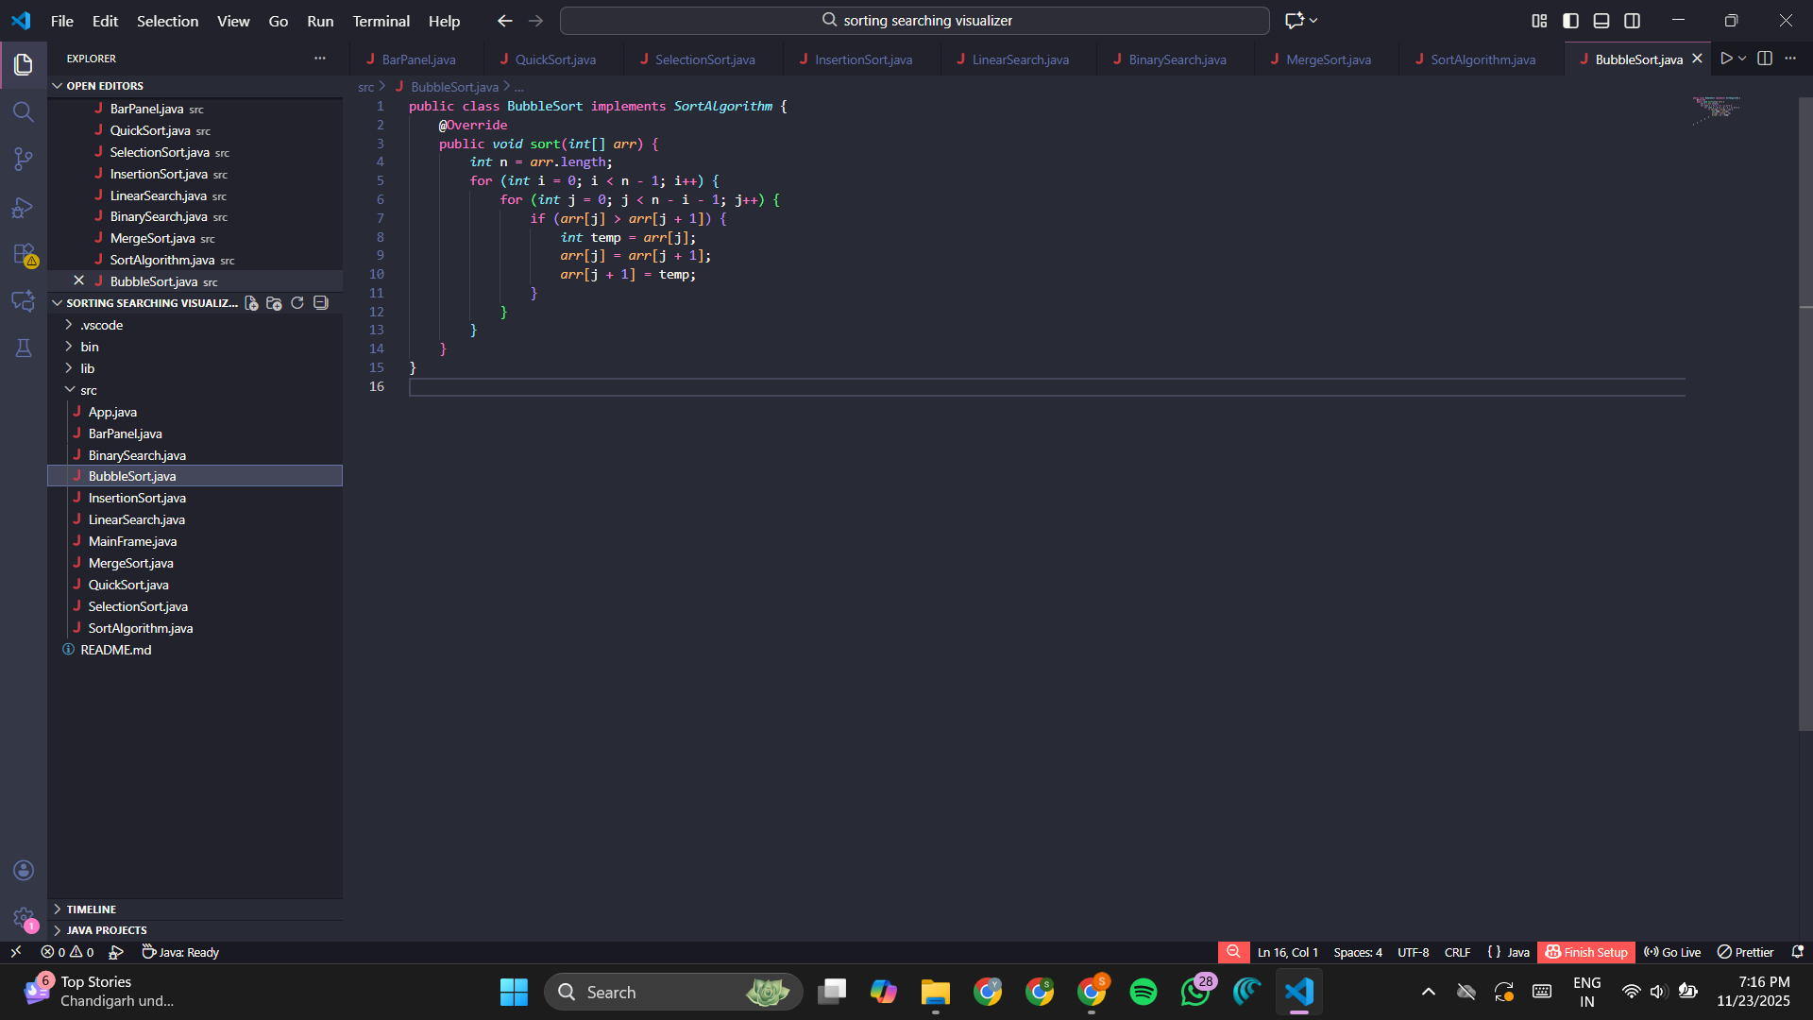
INSERTION SORT
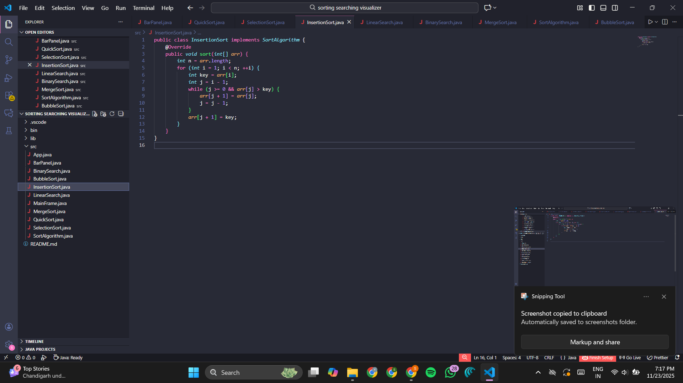
MERGE SORT
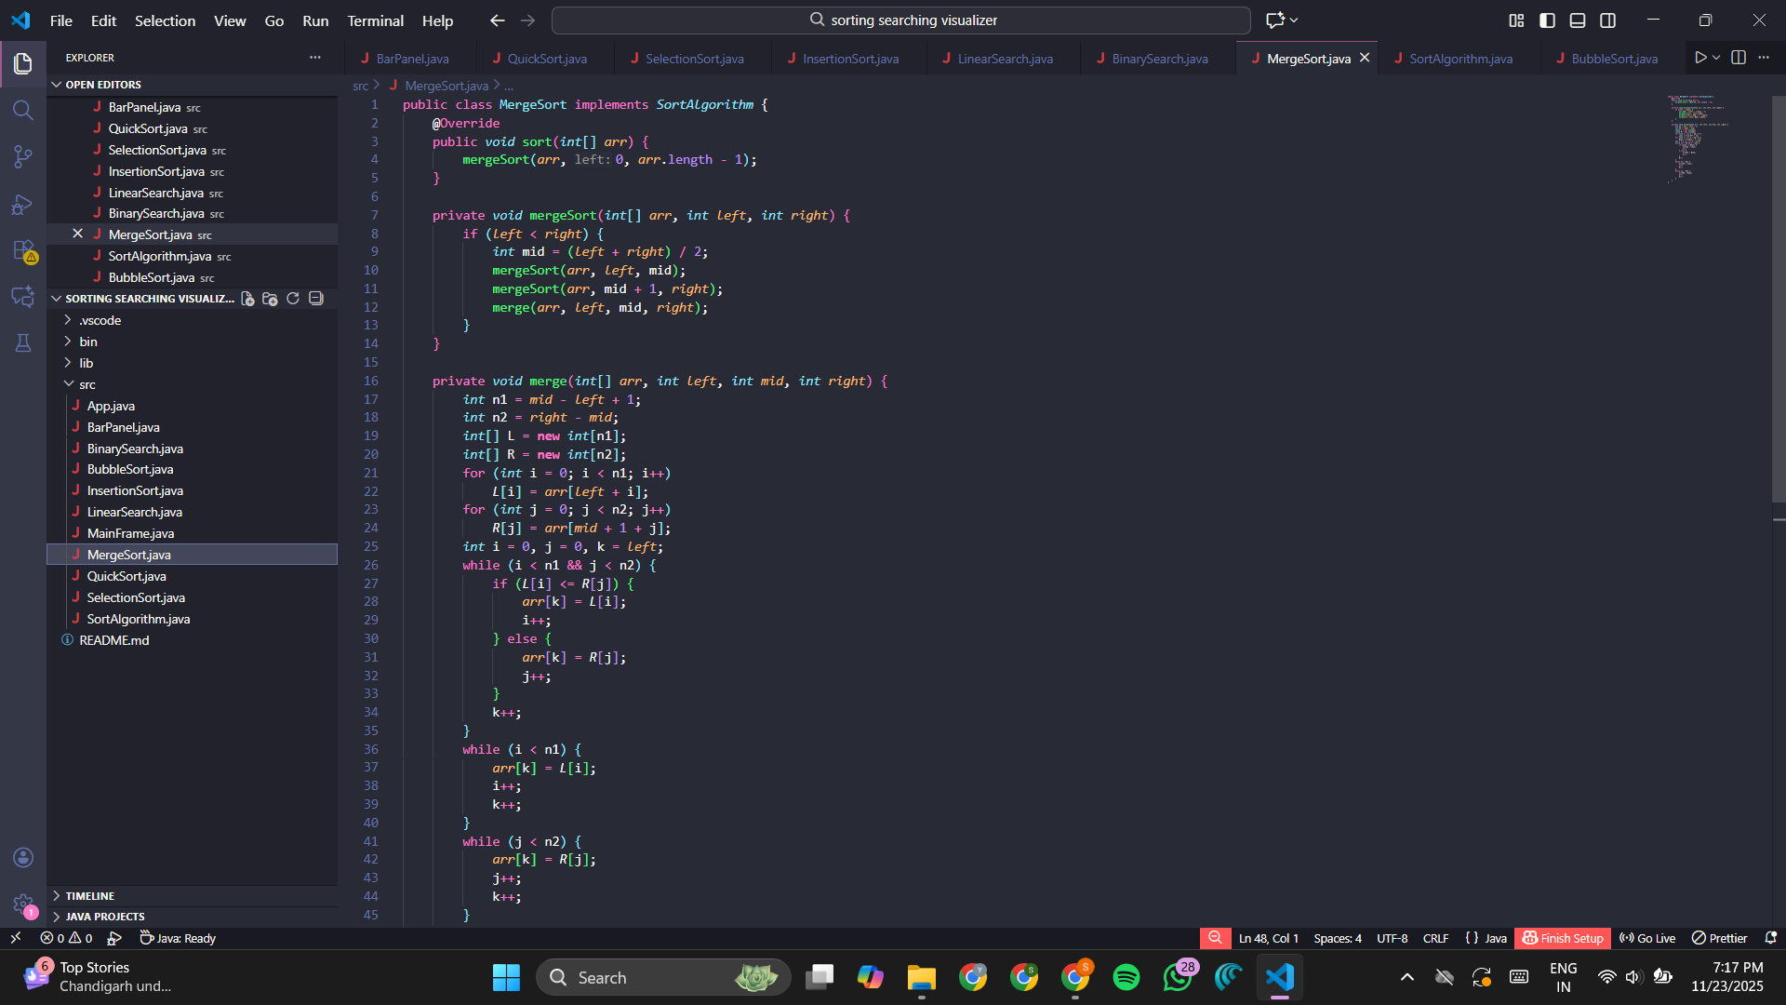

QUICK SORT
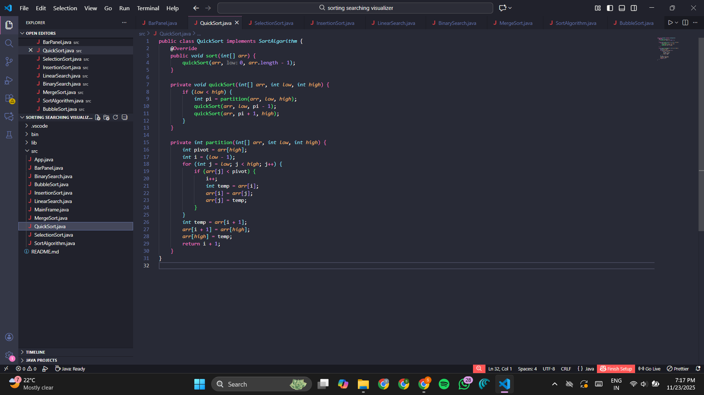

SELECTION SORT
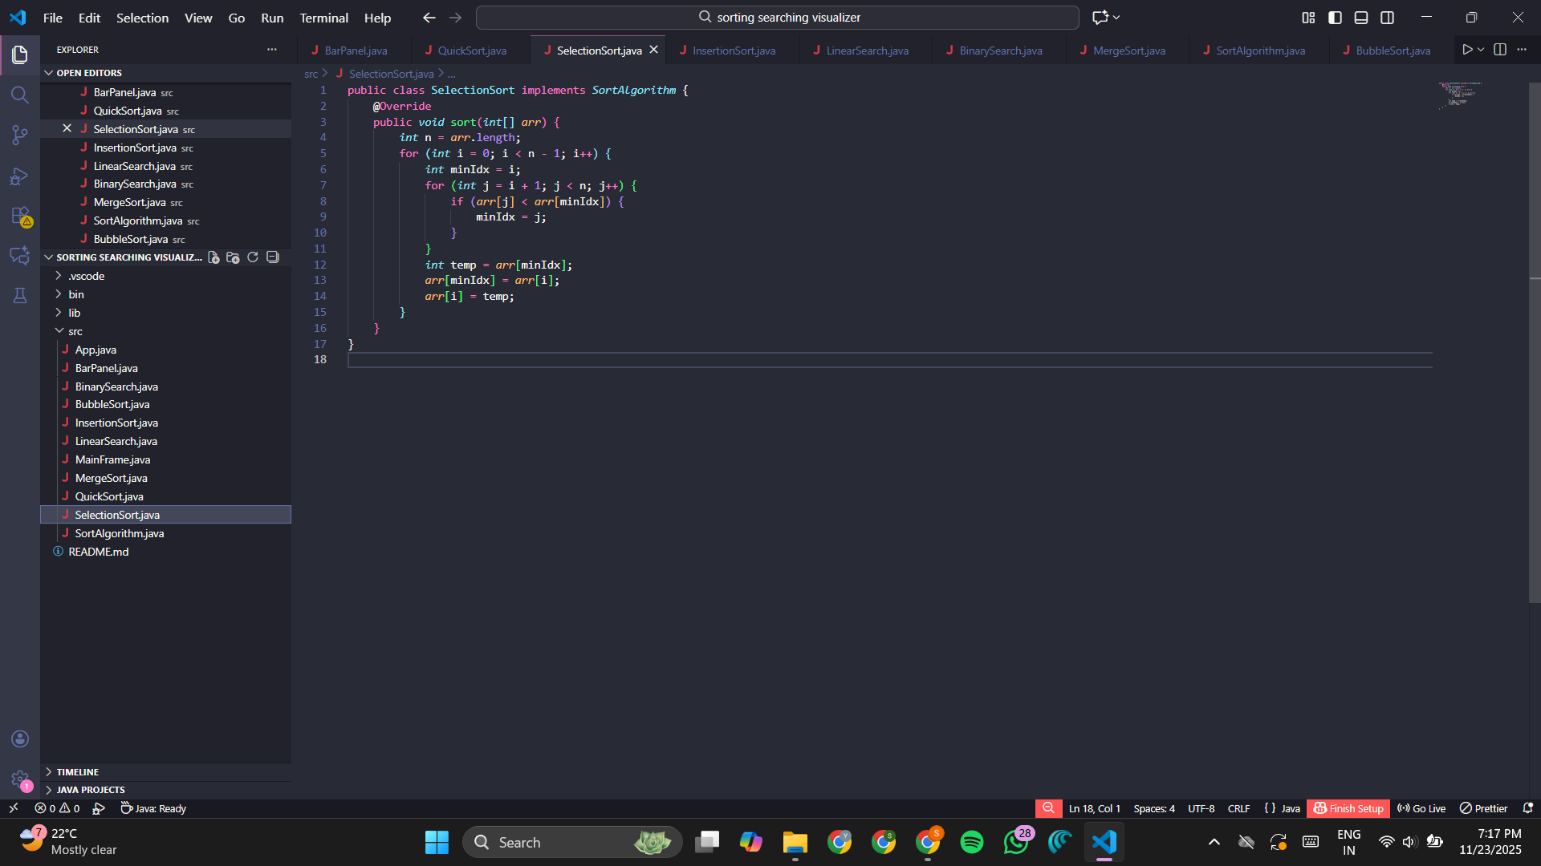

8.2. Searching Algorithms

LINEAR SEARCH
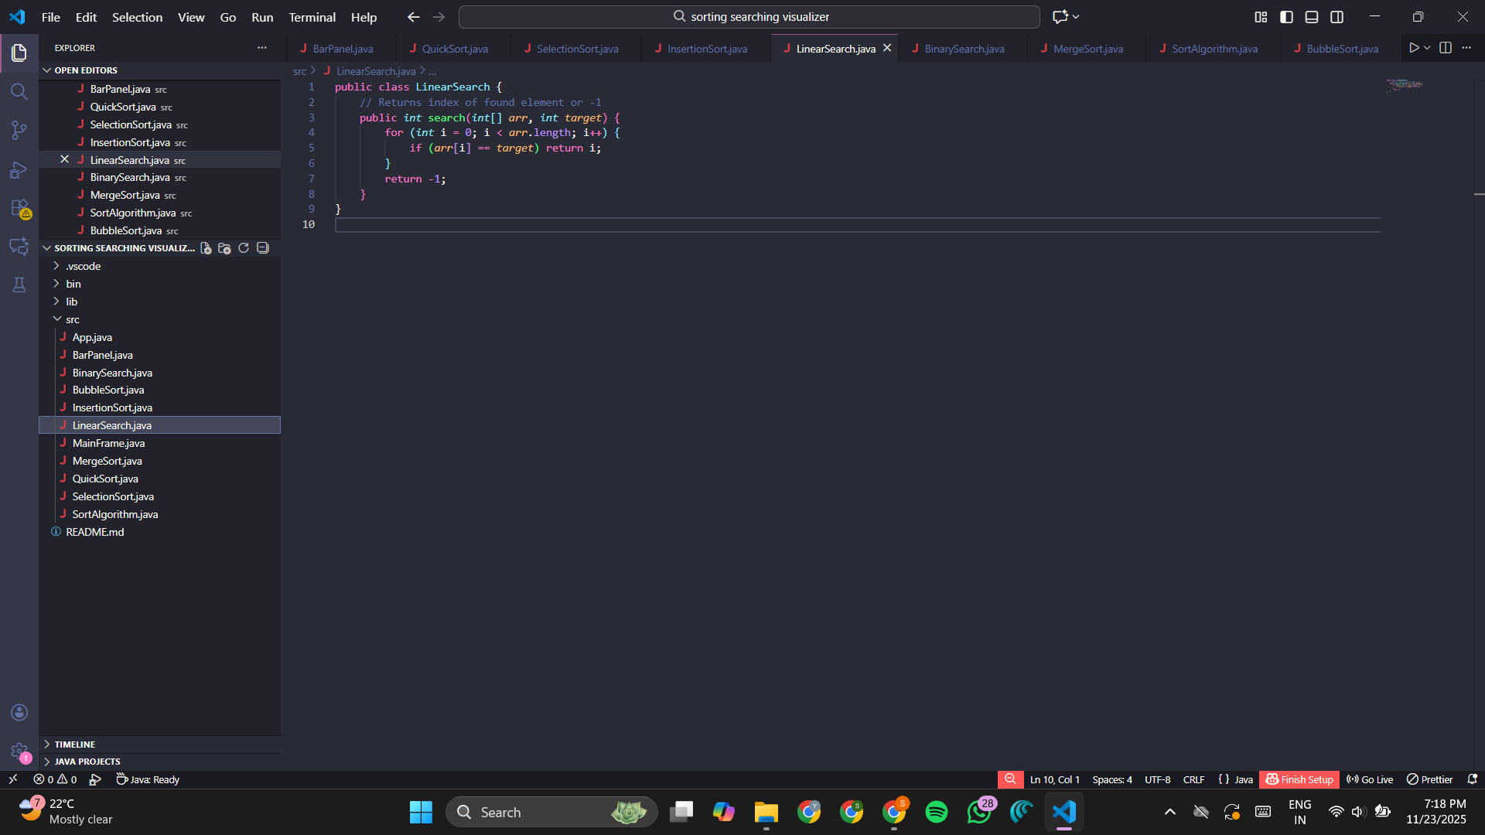

BINARY SEARCH
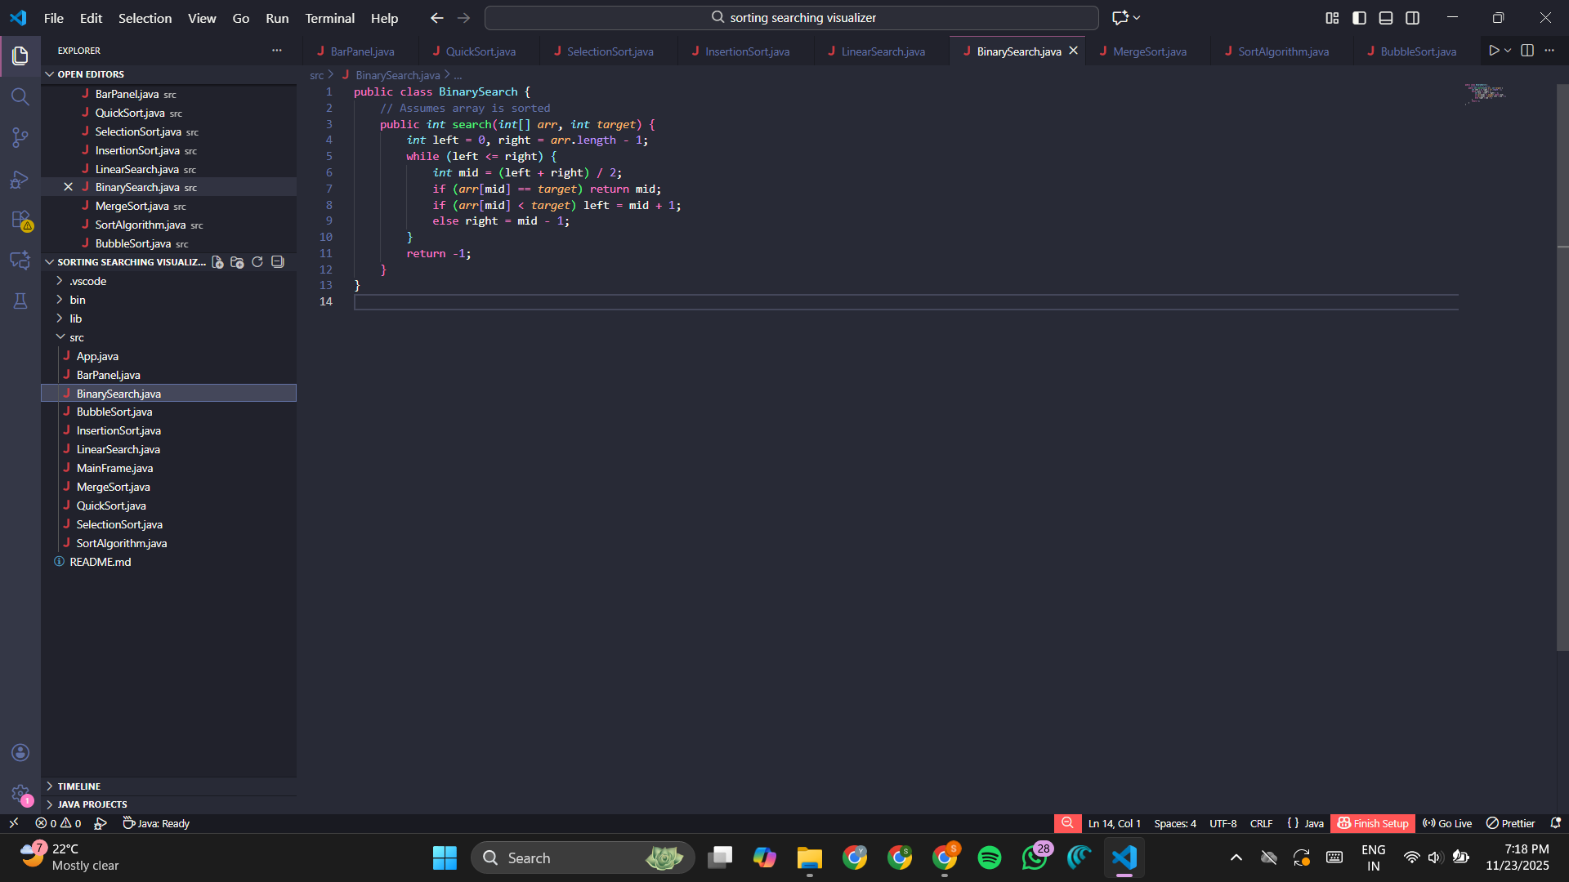

9. Testing and Evaluation
- Manual test cases:
  - Tried custom inputs (edge cases: empty list, duplicates, sorted/unsorted).
  - Used each sort on various list sizes.
  - Verified animated updates matched expected sort step-by-step.
  - Ran both searching methods on different arrays.
- Results:
  - All features function as designed.
  - Visual representation helps in tracing algorithm logic.
  - Output messages and search indices verified for accuracy.

10. OOP Concepts Used
- Abstraction: All sorts implement the SortAlgorithm interface.
- Polymorphism: At runtime, selected algorithm is called via reference to the interface.
- Encapsulation: Each algorithm’s logic is contained in a separate class.
- Inheritance: All sorting classes either directly implement or extend the base algorithm interface/class.
- Modularity: GUI code, sorting logic, and visualization are separated for maintainability.

11. Conclusion
This Java project demonstrates the practical function and inner mechanics of classic sorting and searching algorithms in a vivid, interactive way.
By integrating core OOP concepts with Swing’s graphics capabilities, the application serves as a valuable learning and teaching tool.
It strengthens algorithmic intuition and makes debugging much easier for both students and instructors.
12. Future Enhancements
- Add more complex algorithms (HeapSort, CountingSort, RadixSort).
- Highlight specific bars being swapped or searched (dynamic bar coloring).
- Provide statistics—number of comparisons/swaps per sort.
- Support for larger data sets with zoom/scroll features.
- Option to export animated steps as GIF/video.

